March 18, 2024

Joan Riley, City Manager
City of Sapulpa
425 East Dewey Avenue
Sapulpa, OK 74066
To Whom It May Concern:

Joan Riley, City Manager
David Widdoes, City Attorney
Shirley Burzio, City Clerk
Mark Lawson, Economic Development Director

Mike Reed, Police Chief
James Vickrey, Fire Chief
Ella Fast, Finance Director

City Councilors
Ward 1–Elizabeth Nicholas
Jeff Molina
Ward 2– Vice May. Carla Gunn
Brian Stephens Ward 3–Alexander Hamilton
Marty Cummins
Ward 4–Mayor Craig Henderson
Richard Hudson
Ward 5–David Mortazavi
Hugo Naifeh

The City of Sapulpa is accepting proposals for its sale of and the bidder’s acquisition of the real property located at 108 East Dewey, Sapulpa, Oklahoma. All interested bidders must submit a sealed proposal in accordance with the attached Request for Proposal and submit it to the attention of Joan Riley, City Manager, Sapulpa City Hall, 425 East Dewey, Sapulpa, OK 74066, no later than 3:00 p.m. CDST on April 15, 2024. No proposals will be accepted for consideration after the specified time. All proposals will be evaluated only on the criteria identified in the Request for Proposal. Any proposal not fully addressing each criterion will be considered a non-responsive offer and will be eliminated from further consideration.

All qualified bidders will be considered without regard to age, race, creed, color, sex, handicap, or national origin.

The CITY reserves the right to reject any and all proposals with or without cause and to waive any informalities.

The CITY will notify all unsuccessful bidders of the contract award after a successful proposal has been accepted and the contract is executed.

Questions concerning the Request for Proposal may be addressed to Joan Riley, City Manager, at the address listed above or at (918) 224-3040 or emailed at JRiley@SapulpaOk.gov .

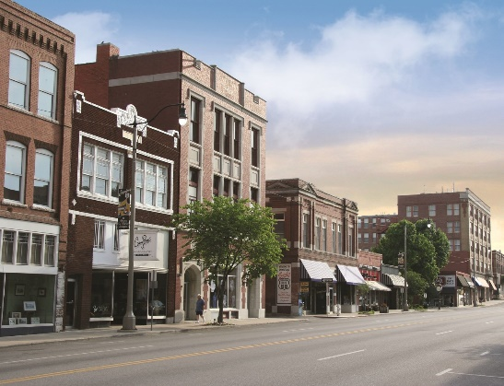

REQUEST FOR PROPOSAL

I. INTRODUCTION

The City of Sapulpa (hereinafter referred to as CITY) will accept sealed proposals until 3:00 p.m. CDST on April 15, 2024, from qualified bidders for entering into a contractual agreement for the performance of the hereinafter described purchase. The real property that is the subject of this Request for Proposal (hereafter referred to as RFP) is 108 East Dewey, Sapulpa, Oklahoma, and said property is owned by the CITY. Proposals should be sealed and submitted to Joan Riley, City Manager, Sapulpa City Hall, 425 East Dewey, Sapulpa, OK 74066.

II. GENERAL INFORMATION

The purpose of this RFP is the sale of the real property by the CITY to a qualified purchaser for the development and use of said property by the purchaser. The intent of the CITY is to select the proposal that it deems is the best fit for the use of property and the benefit of the CITY.

All qualified bidders will be considered without regard to age, race, creed, color, sex, handicap, or national origin.

CITY reserves the right to reject any and all proposals received in response to this RFP. A contract for the accepted bidder will be based only on the factors and procedures described in the RFP.

Respondents must include the affidavit attached to this RFP with their submission.

III. QUALIFICATIONS FOR PROPOSAL

Respondents should provide the following items as part of the submitted proposal.

A. Bid Price.
The minimum bid for the purchase of the real property is three hundred sixty-five thousand dollars ($365,000.00).

B. Use of Property.
A detailed description of the bidder’s intended use of the real property. Included herein is the time frame for the bidder to complete all requirements and work necessary for its proposed use of the real property.

C. Qualifications of the Bidder.
This section shall discuss prior relevant experience of the bidder; particular mention should be made regarding previous experience with the type of project proposed. References can be provided along with a list of such projects.

D. Affidavit.
The attached Affidavit shall be completed and submitted with the Proposal.

E. Number of Copies of Proposal.
Six (6) copies of the Proposal shall be submitted, in a sealed envelope.

IV. EVALUATION CRITERIA

All Proposals that are received by the deadline and in the manner required in this RFP will be opened and evaluated by representatives of the CITY. The following criteria will be used for selecting and accepting the winning Proposal:

A. Use of correct format and meeting of required qualifications.

B. The bid price.

C. The proposed use of the property.

D. The Proposal’s ability, likelihood and time frame for achieving the desired outcome of the proposal.

E. The experience and expertise of the bidder as well as past performance of the bidder in similar projects.

F. The Proposal’s overall benefit and enhancement to the CITY.

NOTE: All written material, oral interviews, and other information relative to the RFP will be treated as confidential.

AFFIDAVIT

On behalf of the Bidder I, , of lawful age, being duly sworn upon oath, certify:

A. That I am authorized to submit this bid and to contract on behalf of the Bidder.

B. That neither I nor any member of my firm have paid, given, or donated or agreed to pay, give, or donate to the CITY or any officer or employee of the CITY any money or other thing of value; including any special consideration, either directly or indirectly, in seeking to procure this property.

C. That there has been no attempt by the Bidder to discourage any other potential Bidder from submitting a proposal.

D. That I have read and understand all the information in the Request for Proposal.

E. That the Bidder will, if awarded the contract, perform the requirements of the contract in accordance with all applicable state and federal rules and regulations.

Dated this this ____ day of ____________________ , 2024

__________________________________________
(Bidder’s Firm Name)

_________________________________________
(Signature of Bidder’s Representative)

______________________________________
(Printed Name and Title of Individual Signing)

Subscribed and sworn to before me this ____ day of , 2024.

________________________________
Notary Public

_________________________________
My Commission Expires

